PC Assembly and Disassembly

Introduction
A desktop computer contains multiple hardware components that work together to perform computing tasks. This assignment explains the major internal components of a PC, the steps involved in safely disassembling and reassembling a desktop computer, and the safety precautions required during the process.

Main Components Found Inside a Desktop PC
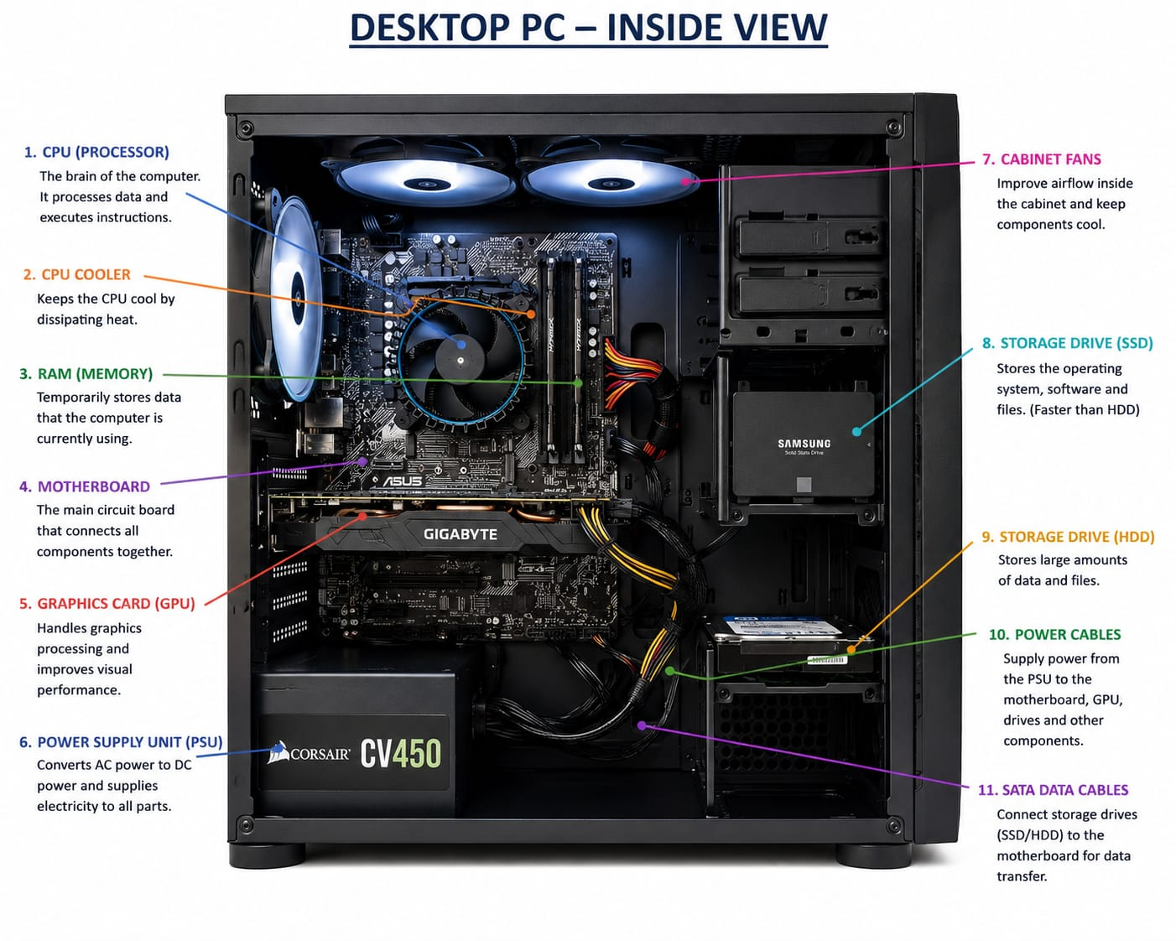

After opening the desktop PC cabinet, the following main components can be identified:
S.No. | Component | Description
1 | CPU (Processor) | The Central Processing Unit (CPU) is the brain of the computer. It processes data, executes instructions, and performs calculations required by software and the operating system.
2 | CPU Cooler | The CPU cooler consists of a heatsink and fan that remove heat generated by the processor. It helps maintain safe operating temperatures and prevents overheating.
3 | RAM (Memory) | Random Access Memory (RAM) temporarily stores data and programs currently being used by the computer. More RAM allows smoother multitasking and faster performance.
4 | Motherboard | The motherboard is the main circuit board that connects all hardware components. It allows communication between the CPU, RAM, storage devices, and expansion cards.
5 | Graphics Card (GPU) | The Graphics Processing Unit (GPU) handles graphics rendering, video processing, and gaming performance. It improves visual quality and supports graphics-intensive applications.
6 | Power Supply Unit (PSU) | The PSU converts AC power from the wall outlet into DC power required by computer components. It supplies electricity to the motherboard, storage devices, and graphics card.
7 | Cabinet Fans | Cabinet fans improve airflow inside the computer case. They help remove hot air and bring in cooler air to maintain stable temperatures.
8 | SSD (Solid State Drive) | The SSD stores the operating system, applications, and files. It provides faster boot times and quicker data access than traditional hard drives.
9 | HDD (Hard Disk Drive) | The HDD is a storage device used for storing large amounts of data such as documents, videos, games, and backups. It offers higher storage capacity at a lower cost.
10 | Power Cables | Power cables connect the PSU to the motherboard, GPU, storage drives, and other components, supplying the electricity needed for operation.
11 | SATA Data Cables | SATA cables connect storage devices such as SSDs and HDDs to the motherboard, enabling data transfer between the storage device and the system.

2. Desktop PC Disassembly Process
Step 1: Shut down the PC and unplug the power cable.
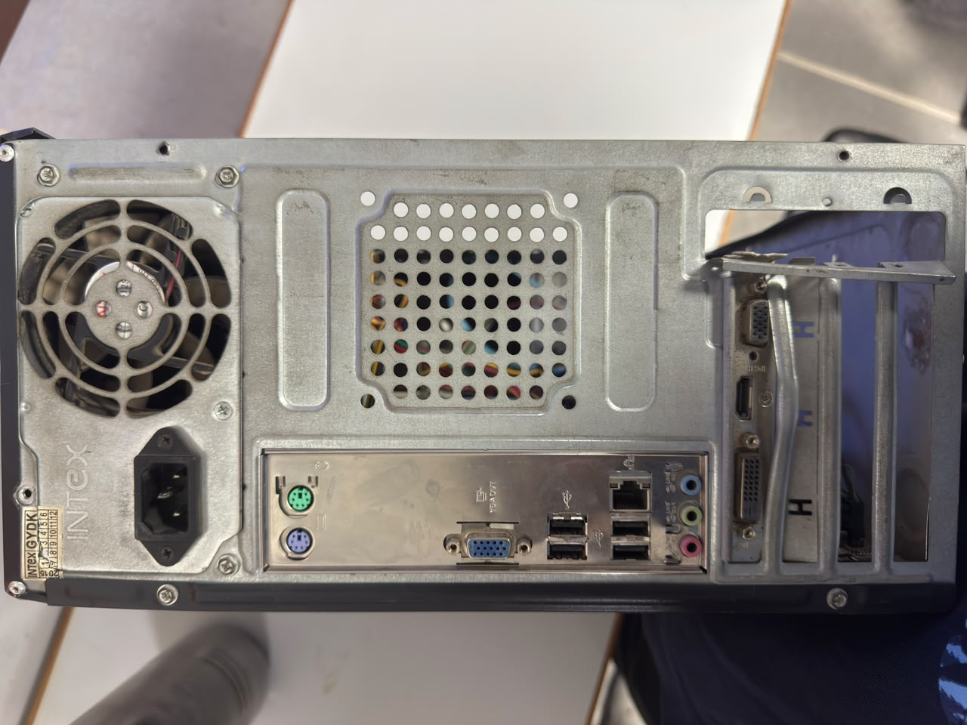

Step 2: Remove the cabinet side panel.
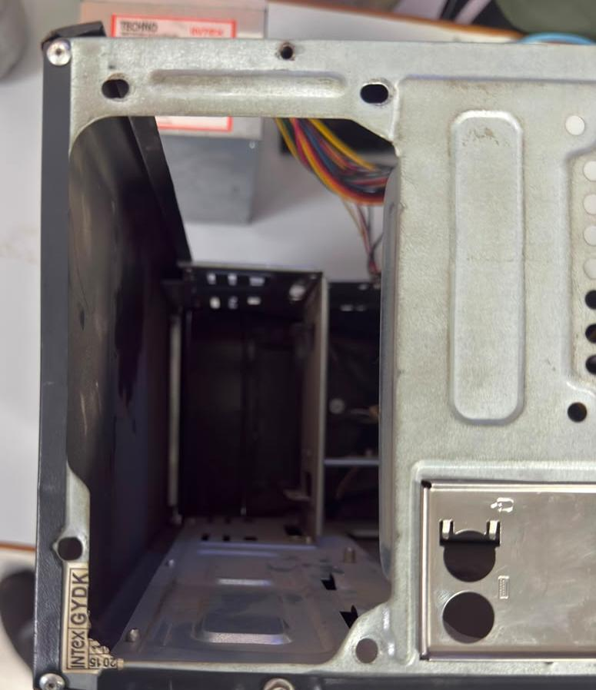
Step 3: Take a photo of the internal components.
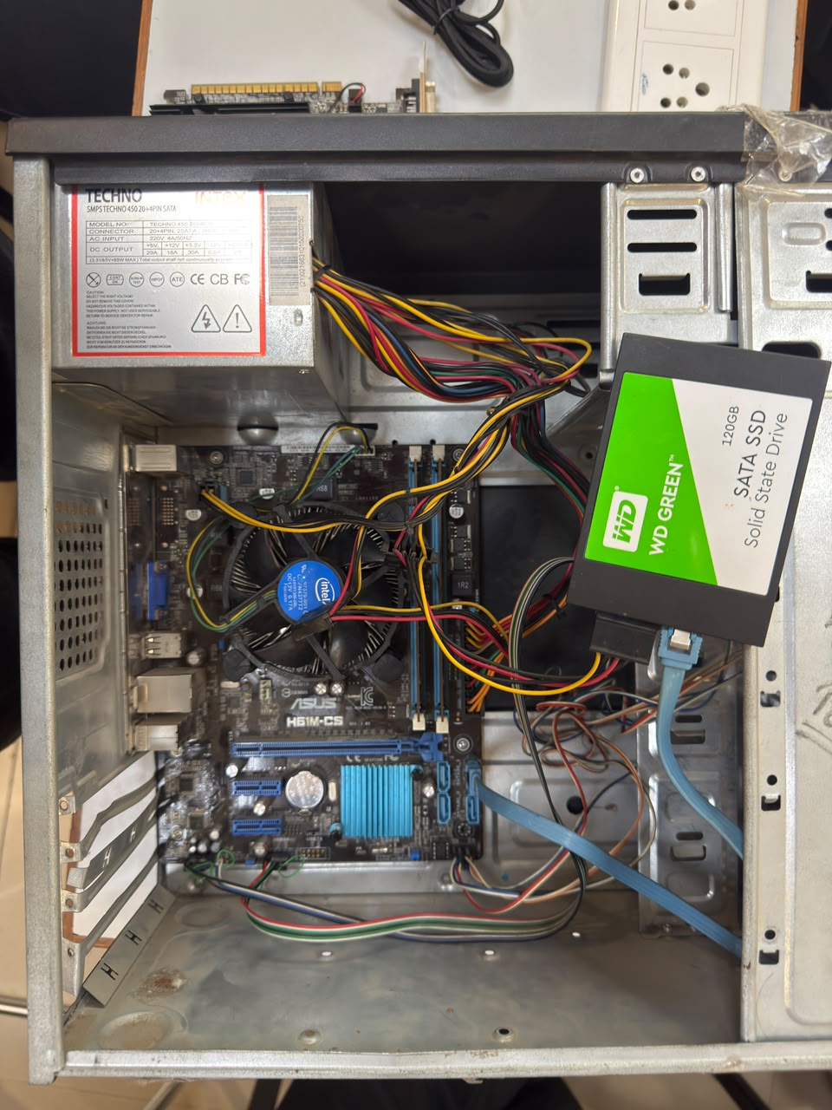
Step 4: Disconnect power cables from components.
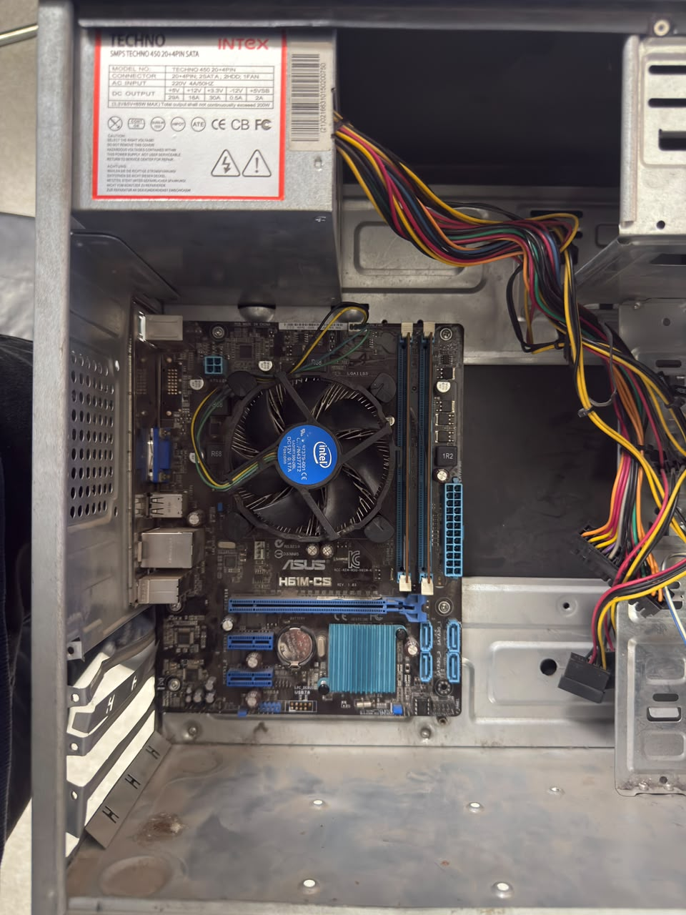
Step 5: Remove RAM modules.


Step 6: Remove HDD/SSD and disconnect cables.

Step 7: Remove the graphics card if installed.

Step 8: Remove the CPU cooler.
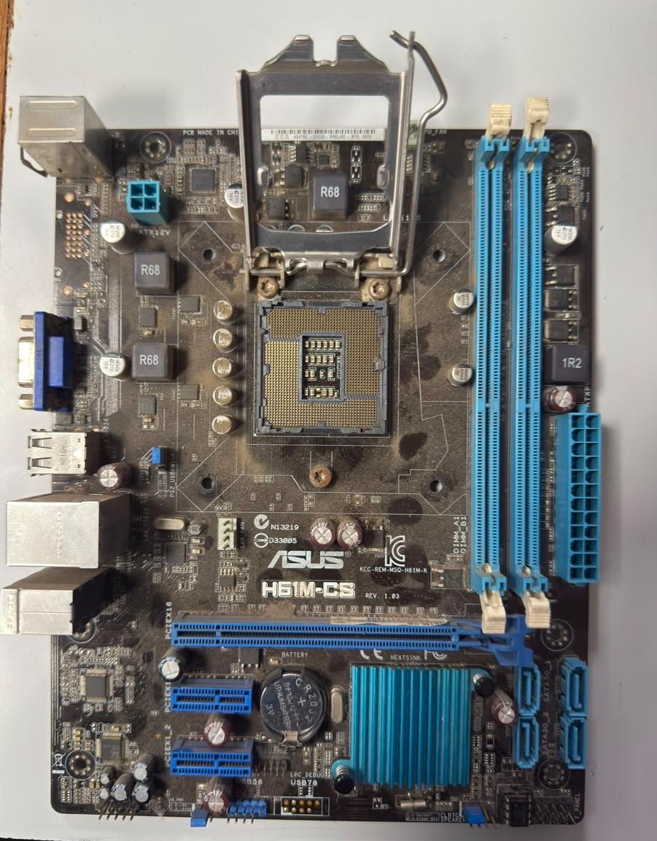
Step 9: Remove the motherboard.



3. PC Reassembly Process
Step 1: Install the motherboard.

Step 2: Install CPU and CPU cooler.

Step 3: Insert RAM modules.
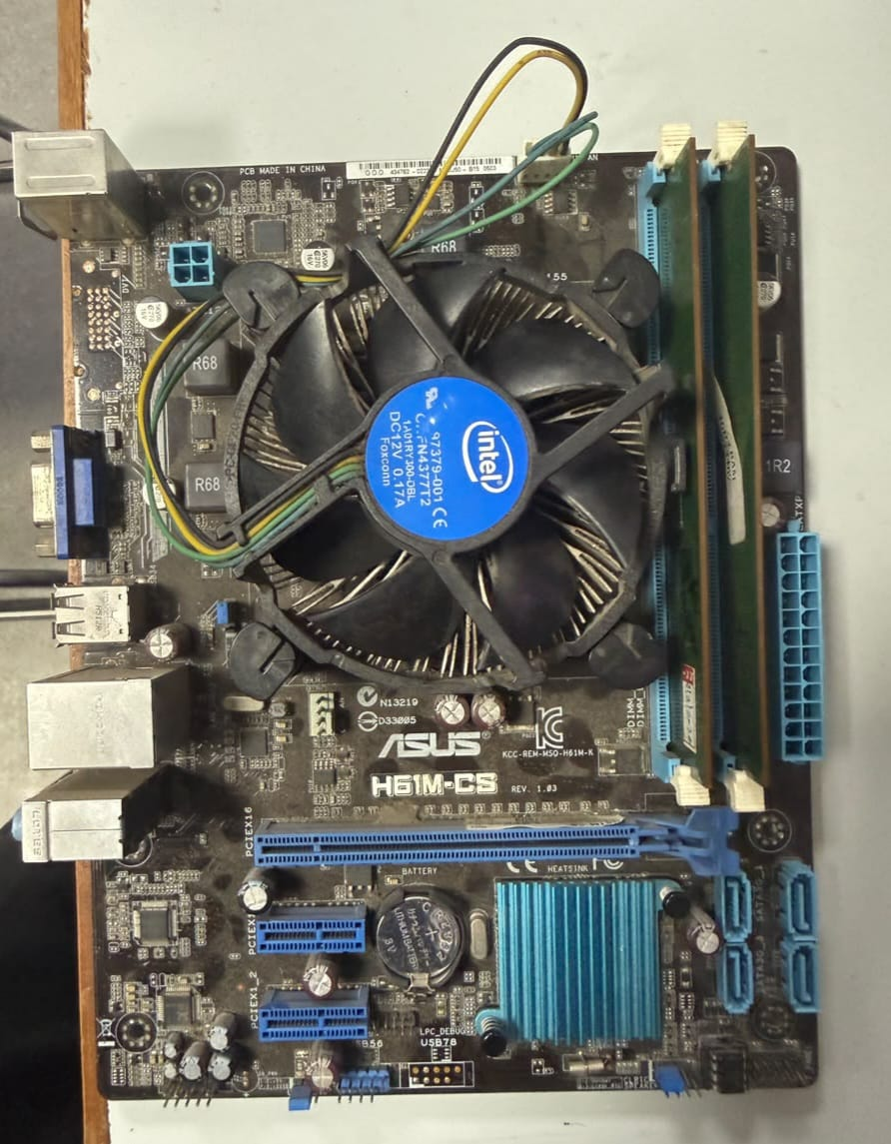
Step 4: Install graphics card.
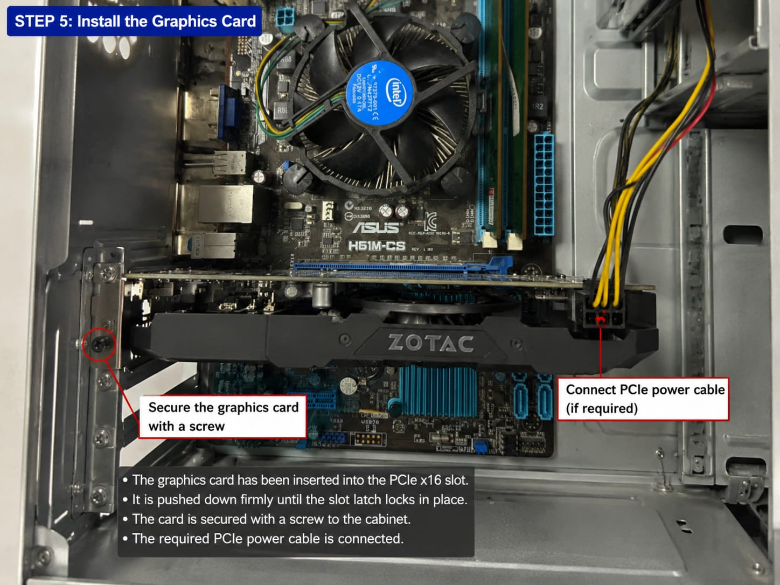
Step 5: Install HDD/SSD.

Step 6: Reconnect power and data cables from panel, USB & Audio Cables
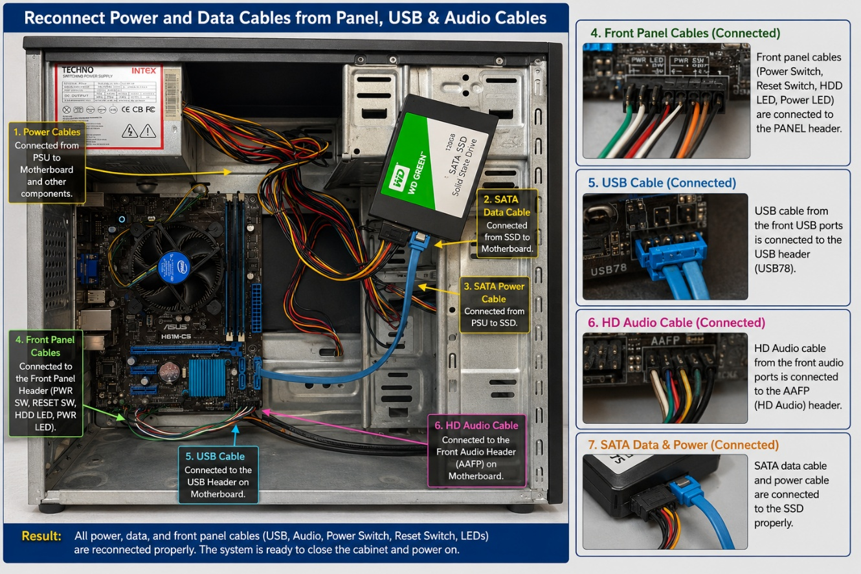
Step 7: Close the cabinet and boot the system.
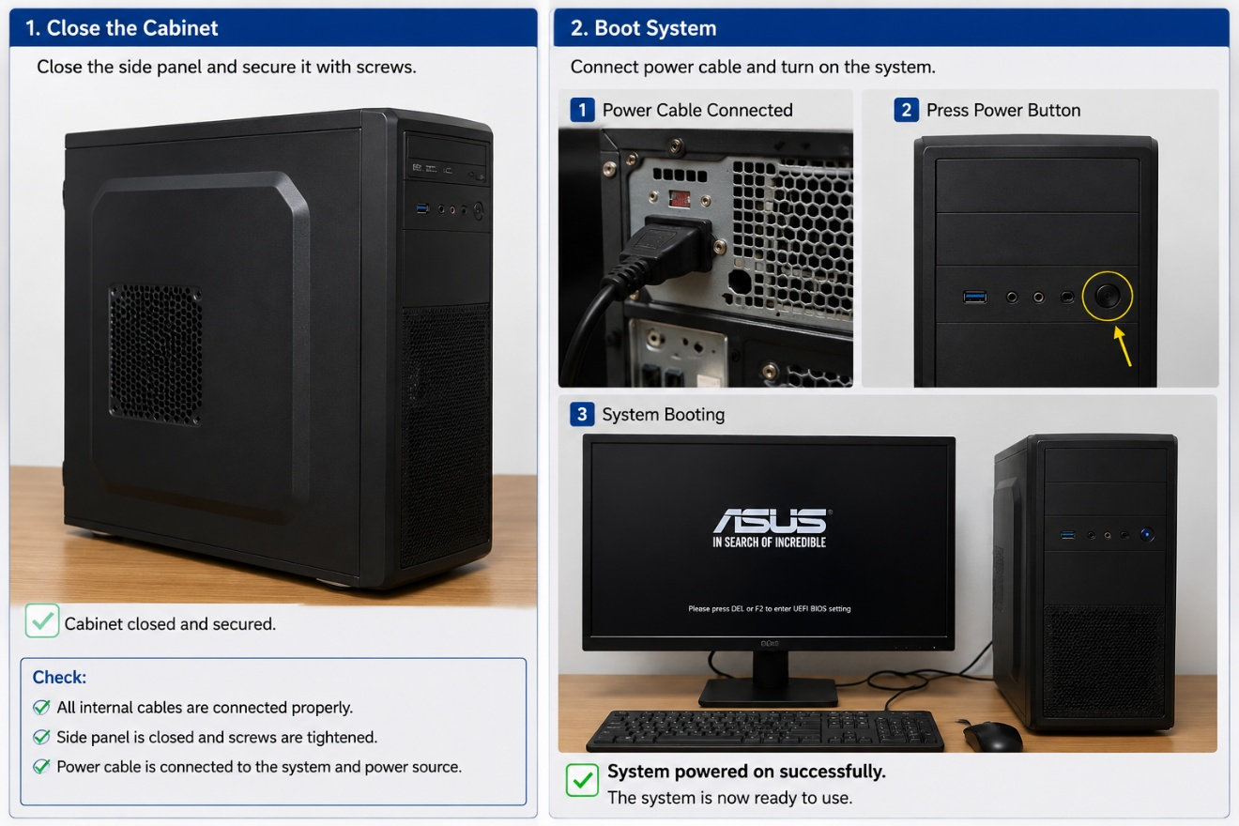
The order matters because some components become difficult to access after others are installed. Following a proper sequence helps avoid mistakes and hardware damage.

4. Safety Precautions and Required Tools
Introduction
Before assembling or disassembling a PC, it is important to follow proper safety procedures and gather the necessary tools. This helps prevent damage to computer components, protects the user from electrical hazards, and ensures that the work is completed efficiently and correctly.
Tools Needed
- Anti-static wrist strap – Prevents static damage.
- Phillips screwdriver – Removes and installs screws.
- Anti-static mat – Protects components from ESD.
- Small container – Keeps screws safe.
- Compressed air – Cleans dust.
- Thermal paste – Needed if reinstalling the CPU cooler.
Safety Precautions
- Turn off and unplug the PC.
- Press the power button to discharge remaining power.
- Work on a clean, dry surface.
- Wear an anti-static wrist strap.
- Handle parts by the edges.
- Keep liquids away.
- Do not force components.
- Check all connections before turning the PC on.
Why These Precautions and Tools Matter
1. Preventing Static Damage
Computer components such as RAM, CPU, and motherboard are highly sensitive to static electricity. An anti-static wrist strap safely grounds the user and reduces the risk of damaging expensive hardware.
2. Protecting Components
Using the correct screwdriver and handling parts carefully prevents scratches, bent pins, and broken connectors during assembly or disassembly.
3. Improving Safety
Disconnecting power and keeping liquids away from the workspace minimizes the risk of electric shock and accidental short circuits.
4. Maintaining System Performance
Cleaning dust with a soft brush or compressed air improves airflow and cooling efficiency, helping the PC run at optimal temperatures.
5. Ensuring Easy Reassembly
Keeping screws organized and following the manual makes it easier to put the computer back together correctly without missing any parts.

Conclusion
Following proper safety precautions and using the right tools before starting PC assembly or disassembly helps protect both the user and the computer hardware. Careful preparation reduces the risk of accidents, prevents component damage, and ensures a smooth and successful maintenance process.

